At our weekly meeting on 3/18, we discussed robot motion and location tracking. When we program for robotics, we sometimes will run into problems relating to driving in a perfectly straight line and turning to an exact angle. We can solve these problems with PID and an inertial sensor. Instead of just going forward in a “straight” line, we can go back and forth in a zig-zag pattern. This ensures that at the end, we will be extremely close to our target end point.

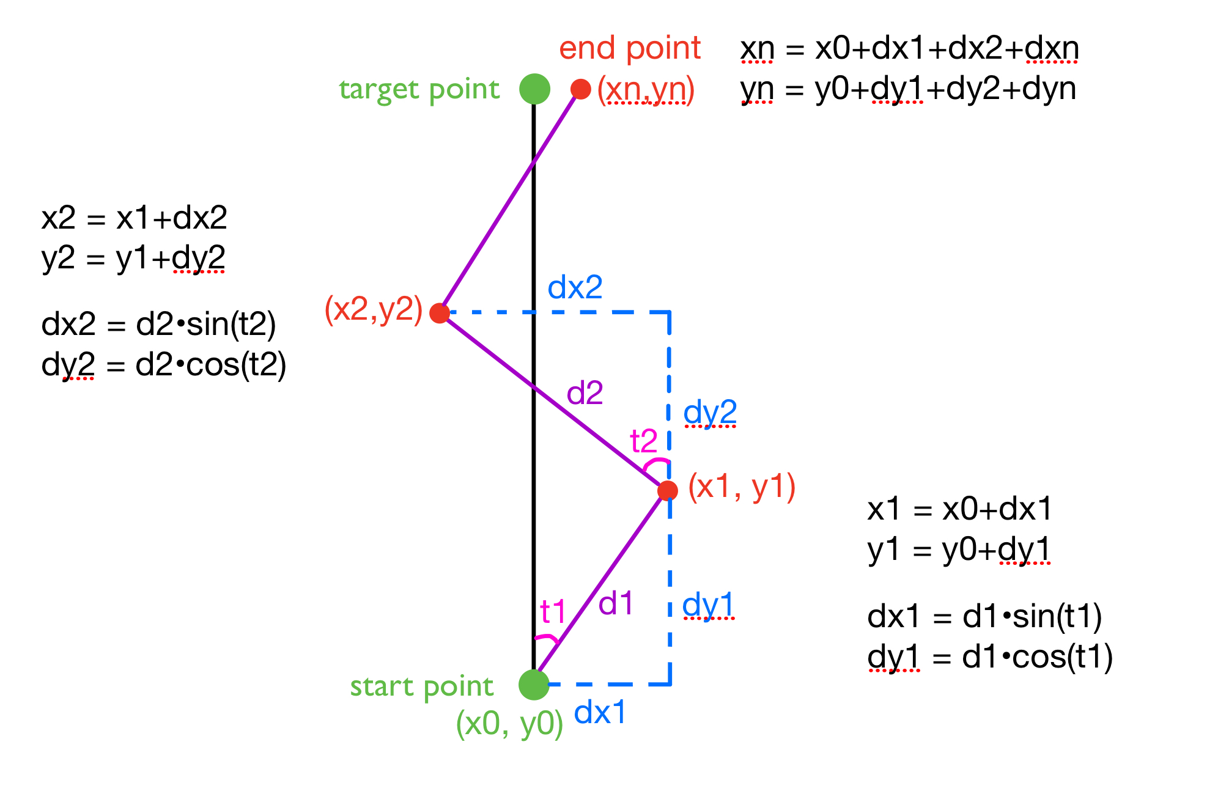

In order to program this into our robot, we can use a while loop to drive the robot from the source to the destination through multiple steps. Each step calls the function goStraight, which calculates the current coordinate (xi, yi).

Pseudo code:

Coord currentCoord = src; //coordinate

While ( dist > 0.01) {

currentCoord = goStraight(dist, currentCoord);

Dist = sqrt( (currentCoord.x -dest.x) ^2 + (currentCoord.y-dest.y)^2 )

}